FISHTAIL BURNER Group F-1 Fishtail Burner.
......Machine Mounting...... Range: Oxy-Gas. Pre-Mix.
Piloted flame type.
Stainless Steel.
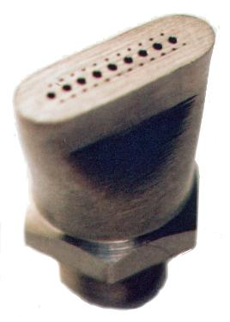
Typical applications include:
Vials and Ampoules on Rotary Index
and Walking Beam Machines.
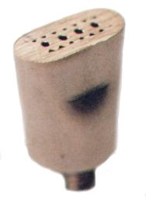
Shaping and Forming of Lamps and
Lighting components.
Laboratory Glassware manufacturing.
Automated and low volume production
of Tabletop Glassware and Containers.
Steel heat treatment and Metal Joining
processes.

1081 1012

Cat.No. Type. No. of # Kcal/hr A B C D E F G
Holes Drill nominal
F001 1012 4 64 1575 6.7 14.5 22 16 6.4 6.4 1/4X26 tpi
F002 1012-B 4 74 525 6.7 14.5 22 16 6.4 6.4 1/4X26 tpi
F003 1012-C 6 78 394 6.7 14.5 22 16 6.4 6.4 1/4X26 tpi
F004 1012-E 5 78 370 5.2 14.5 22 16 6.4 6.4 1/4X26 tpi
F005 1012-F 5 71 920 5.2 14.5 22 16 6.4 6.4 1/4X26 tpi
F006 1012-G 4 64 1706 5.2 14.5 22 16 6.4 6.4 1/4X26 tpi
F007 1012-H 5 78 370 5.2 14.5 22 16 6.4 6.4 1/4X26 tpi
F008 1012-J 6 70 1312 5.6 14.5 22 16 6.4 6.4 1/4X26 tpi
F009 1081 9 62 3000 15.5 20.5 33 20.5 9.5 7.9 1/8BSPint.
F010 1081-A 9 62 3000 15.5 20.5 33 20.5 9.5 7.9 1/4BSPext.
F011 1081-B 9 62 3200 13 20.5 33 20.5 9.5 7.9 1/4BSPext.
F012 1081-C 9 74 3200 15 20.5 33 20.5 9.5 7.9 1/4BSPext.
F013 1081-E 5 62 2300 15.5 20.5 33 20.5 9.5 7.9 1/4BSPext.
F014 1081-F 10 71 1600 15.5 20.5 33 20.5 9.5 7.9 1/4BSPext.
F015 1081-BD 9 62 3000 15.5 20.5 33 20.5 9.5 7.9 1/8 int. x ¼ ext.
Type 1012 is also available with M6x1 ext. thread and 1/4x27 tpi ext thread. Type 1081 is also available with NPT ext. thread.

Type Flame Pattern Type Flame Pattern
1012 Divergent 1081 Divergent
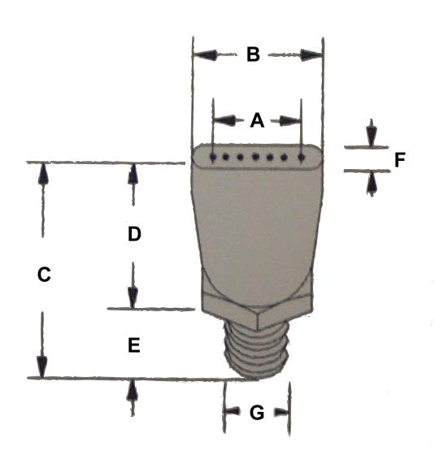
1012-B Divergent 1081-A Divergent
1012-C Parallel 1081-B Parallel
1012-E Parallel 1081-C Divergent
1012-f Parallel 1081-E Divergent
1012-G Parallel 1081-F Divergent
1012-H Divergent
1012-J Parallel

To ensure that accurate and constant flame settings
are achieved, all pre-mix Oxy - Gas burners must
operate from a correctly sized venturi mixer, together
with compatible needle type flow control valves.
If necessary, contact the Rapidflame technical office
for assistance or advice on the selection of either new
or existing venturi mixers.

