OPENFLAME BURNER GROUP B-3 single jet.
......Spear Point Flame...... Range: SPF.6 to 75 [¼” to 3”]
Pre-Mix. Air-Gas.

Manufactured from Stainless Steel and designed for operating with a highly stable spearpoint shaped flame with a wide turn-down ratio, this burner nozzle offers excellent resistance when used in a corrosive environment or high temperature atmosphere. Pre-mixing with combustion air is complete with a fan, blower or compressed air supply to the venturi mixer. Mainly used with either Natural or Propane gas this type of nozzle provides an ideal assembly when combined with the Rapidflame RAM and VM range of Venturi Mixers and control valves.

Typical applications include:
Immersion tube firing......Kilns......Ovens......Preheating lances.
Foundry ladle heating......Pilot burner assemblies......Cremators......Furnaces.
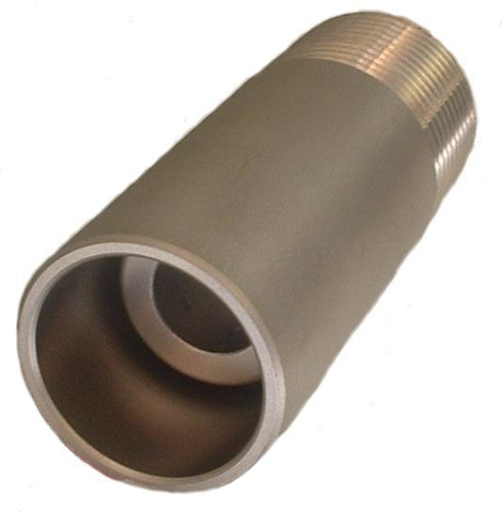

SPF-25M

External thread connection
Cat. Type. Thread Overall Kcal/Hr.
No. size length nominal
B030 SPF-6M ¼” bsp 40 1250
B031 SPF-9M 3/8” bsp 72 2500
B032 SPF-12M ½” bsp 76 7500
B033 SPF-19M ¾” bsp 76 15000
B034 SPF-25M 1” bsp 90 22000
B035 SPF-32M 1 ¼” bsp 107 45300
B036 SPF-38M 1 ½” bsp 120 71500
B037 SPF-50M 2” bsp 160 113000
B038 SPF-63M 2 ½” bsp 165 220000
B039 SPF-75M 3” bsp 165 375000
Available in carbon steel to special order.

Internal thread connection
Cat. Type. Thread Overall Kcal/Hr.
No. size length nominal
B040 SPF-6F ¼” bsp 40 1250
B041 SPF-9F 3/8” bsp 72 2500
B042 SPF-12F ½” bsp 76 7500
B043 SPF-19F ¾” bsp 76 15000
B044 SPF-25F 1” bsp 90 22000
B045 SPF-32F 1 ¼” bsp 107 45300
B046 SPF-38F 1 ½” bsp 120 71500
B047 SPF-50F 2” bsp 160 113000
B048 SPF-63F 2 ½” bsp 165 220000
B049 SPF-75F 3” bsp 165 375000
Available in carbon steel to special order.

The Rapidflame policy is one of continuous development and improvement, we therefore reserve the right to change any specification or design without prior notice.

